How to seal the connectors?
Space-time Optics and Photonics Lab
12/23/2025

We need to use a hermetically sealed throughput connector to properly seal out gas that could escape through the cables and the plug design that was recommended to us. This website shows Douglas electrical diagrams, you can se the general idea of what a hermetically sealed connecter has.
First off using an off the shelve part seems to be the easiest, since we are using a BNC connector, there are BNC to BNC female feedthrough devices, like this 1 inch feedthrough BNC-BNC. The only issue is the 1-inch connector is $161.99. There are a lot of cheaper options on digikey for $8 to $32 Smaller BNC-BNC connectors. Now the thought processed was to thread into the acrylic and then be able to access the interior BNC that way.
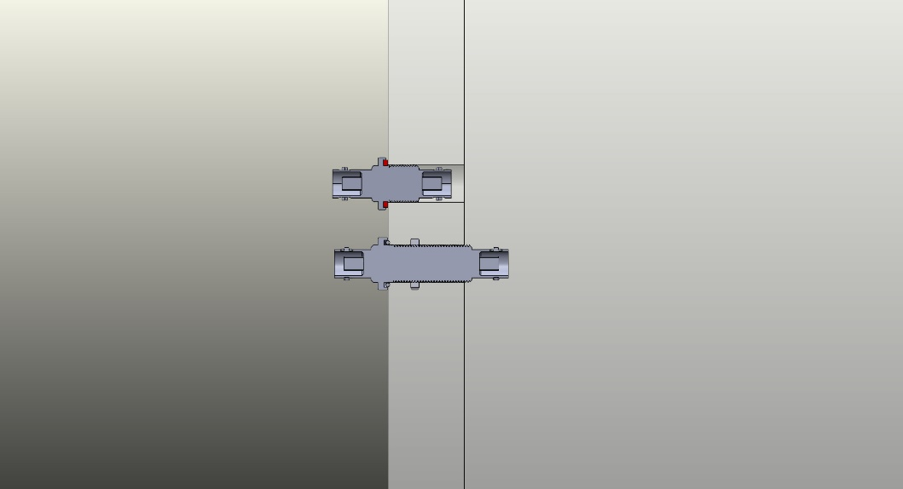
Smaller step file
Now I thought of using an external BNC to an internal solderable connection that we can then coat in epoxy to protect it. This would then be able to be wired up to the piezo with banana plugs or like we have it with the alligator clips. This may also be a cheaper solution BNC to solder.
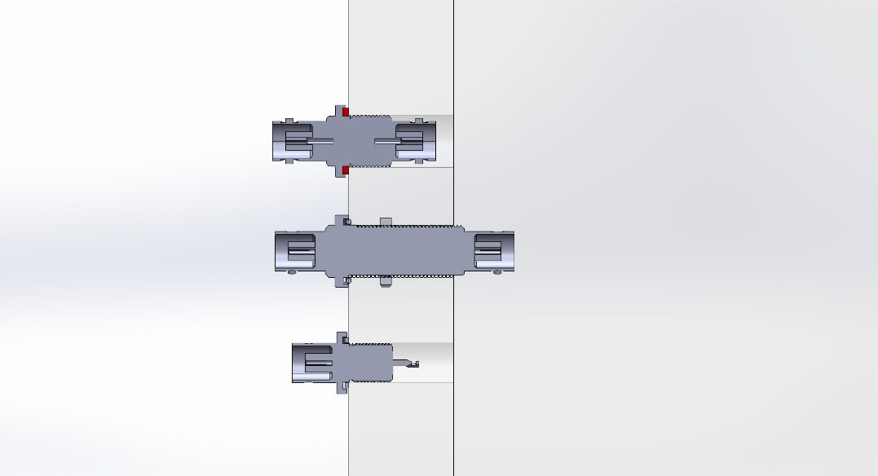
There is this product, I need to get a price, but I am assuming it could be quite expensive, but it will do exactly what we would need from it.
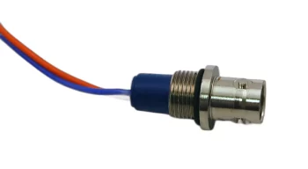
https://douglaselectrical.com/douglas-products/backpotted-connectors/

There are plenty of non-hermetically sealed passthrough connectors that may work for what we need to do in the vacuum chamber, and a little epoxy would probably help seal it. We could also make a passthrough with the rubber plug that we have. And by taking the BNC to two wires we can splice the wire in the middle. Take the spliced wire and put it through the plug and then fill it with epoxy we would have made a hermetically sealed passthrough on the cheap.

Now for the motor control, there are plenty of D type 15 pin passthroughs that are sealed, but it is very expensive. I also need to measure it correctly so it can fit in the 1 inch acrylic, VGA D-sub passthrough.

